Chapter 9, Problem 46.

If i_{s} = 5cos(10t + 40°) A in the circuit in Fig. 9.53, find i_{o}.

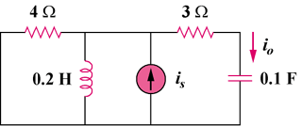

Figure 9.53
For Prob. 9.46.

i_{s}

